

Capstone Project Phase A

24-2-D-21

**CareHub**

Development of an Application for Daily

Management and Support for Parkinson's Patients

**Supervisor: Ph.D. Julia Sheidin**

**Omer Sommerstein -** [**Omers354@gmail.com**](mailto:Omers354@gmail.com)

**Aviram Fishman -** [**Aviram.Fishman@e.braude.ac.il**](mailto:Aviram.Fishman@e.braude.ac.il)

**Table of Content:**

1. Abstract ………………………………………………………………………………... 3

2. Introduction …………………………………………………………………………… 3

3. Related Work and Background ………………………………………………………... 4

3.1 Impact on Parkinson's Disease Patients ………………………………….…… 4

3.2 Parkinson's Disease Management ……………………………………….……. 4

3.3 Supporting the Need for Software Solutions …………………………….…… 5

3.4 Existing Solutions ……………………………………………………….….… 7

3.5 Summary ………………………………………………………………...…... 12

4. Expected Achievements ……………………………………………………………... 12

5. Research and Engineering Process …………………………………………...……… 13

5.1 Process …………………….……………………………….…………...…… 13

5.2 Product ……………………....………………………………………….…… 18

6. Diagrams ………………………………….…………………………………….……. 19

6.1 Use Case ………………………………………………………………….…. 19

6.2 GUI Prototype …………….…………...……………………………….……. 24

7. Evaluation / Verification Plan ………………………………………………………... 35

7.1 Testing Plan ……………………………...……………………………...…... 35

7.2 Evaluation by User ………………………………………………….………. 37

8. References …………………………………………………………………………… 38

9. Appendix …………………………………………………………………………...... 40

1. Abstract

Parkinson's disease is a neurodegenerative disorder that significantly impairs a patient's motor abilities, resulting in symptoms such as tremors, muscle stiffness, and slowness of movement. Patients with Parkinson's disease experience two distinct states: an “ON” state, where they can perform their daily activities like driving, cooking, and walking according to their lifestyle and disease severity, and an “OFF” state, where they cannot carry out these activities. Currently, there is no cure for Parkinson's disease; various medications can help affect the “ON” state. Research has shown that a combination of physical exercise, proper nutrition, social interactions, and complementary treatments within the community can positively impact patients with Parkinson's. Consistent management through obtaining indicators on the lifestyle of a Parkinson's patient provides various indications that affect the patient. Traditional methods, such as manual record-keeping or existing applications, often fail to meet the specific needs of Parkinson's patients, leading to challenges that negatively impact their quality of life. This project aims to provide a technological solution that empowers individuals with Parkinson's disease by simplifying the management of their daily lives.

Our goal is to develop a user-friendly system that significantly improves the quality of life for Parkinson's patients. The system will enable them to enter essential health and lifestyle data efficiently, with minimal effort, and retrieve this information as needed. Additionally, caregivers, including family members and healthcare professionals, will have access to this data, facilitating better support and care.

The project addresses key barriers to technology adoption among Parkinson's patients, including cost, training, accessibility, and maintenance. By incorporating software engineering best practices and user-centered design principles, we aim to create an effective, efficient, and easy-to-use platform for patients and caregivers. Ultimately, this system is designed to become a leading platform in the field, setting a new standard for how technology can enhance the daily lives of those living with Parkinson's disease.

Keywords: Parkinson Disease, Parkinson's Disease Management, User-Centered Design, UI for Parkinson's Patients, Healthcare Technology, Symptom Tracking.

2. Introduction

Parkinson's disease (PD), the second most common neurodegenerative disorder, predominantly affects individuals over 60 and shows a higher prevalence in men (3:2 ratio) [1]. By 2030, the number of PD cases is projected to reach 9 million [2]. This disease significantly impairs motor skills, causing tremors, stiffness, and slowness of movement. PD patients experience two distinct states: the "ON" state, where daily activities like walking and driving are manageable, and the "OFF" state, where these activities become significantly limited. Nowadays, medications can improve the duration of the "ON" state, but there is currently no cure for PD. Research suggests that engaging in physical training [3], maintaining proper nutrition [4], fostering social interactions, and utilizing complementary treatments [3] can positively impact the daily lives of PD patients.

Nowadays, individuals with Parkinson's disease manage their condition by documenting daily events in basic systems like Excel and Google Sheets. These records surround various daily activities, including medication intake, medical appointments, exercise routines, and dietary habits. By analyzing this collected data, Parkinson's patients aim to extend the duration of their "ON" states. They accomplish this by identifying and replicating patterns from days when they experienced better symptom management. The cognitive challenges faced by Parkinson's patients often stop their ability to accurately record events in real-time. This limitation affects the reliability of the collected data and, consequently, the ability to improve their lifestyle. To address this issue, we propose leveraging advanced technologies to more effectively manage the disease, ensuring more accurate and timely data collection and analysis.

Technology can play a key role by monitoring “ON” and ”OFF” states in Parkinson's patients by tracking daily activities. Our suggested solution aims to increase the amount of time the patient spends in the “ON” state by observing the Parkinson's patient's activities to improve their quality of life through our CareHub app.

CareHub is an extensive system designed to support a range of stakeholders, focusing mainly on Parkinson's patients. Patients can input data, making it accessible to other stakeholders to better understand the patient's condition and enhance their quality of life, particularly by increasing the duration of time spent in the "ON" state. Besides the Parkinson's patient, who is the main stakeholder of CareHub there are other stakeholders. Dieticians can access their patient’s data to recommend appropriate diets that support daily functioning, while therapists can use the information to develop personalized exercises aimed at improving the patient's mobility. By collaborating among various stakeholders, CareHub delivers personalized care, significantly increasing the patient's overall quality of life.

3. Background and Related Work

Parkinson's disease has been a part of human history for centuries, with the first clear medical description dating back to James Parkinson's "An Essay on the Shaking Palsy" in 1817 [5]. Despite extensive research, a cure has not been found yet. However significant progress has been made over the years in managing the disease and improving patients' quality of life through medication and lifestyle adaptations. Studies have shown that creating a lifestyle tailored to the nature of the disease can significantly contribute to extending the "ON" state, where symptoms are well-controlled [6].

3.1 Impact on Parkinson's Disease Patients

Parkinson's disease (PD) significantly impacts patients' lives, affecting both motor functions like trembling, muscle stiffness, and slow movement, as well as non-motor functions, including sleep disturbances, cognitive changes, and mood disorders [7]. These symptoms collectively impair daily activities, such as personal hygiene and driving, leading to social isolation, emotional distress, and financial challenges like early retirement or job loss [8]. While treatments can help manage symptoms, they also present challenges, including medication side effects and the need for frequent medical care [9]. The progressive nature of PD requires patients and their families to continually adapt to new challenges, significantly affecting their quality of life and independence over time [8].

3.2 Parkinson's Disease Management

Consistent adherence to prescribed medications is crucial for symptom control, with studies showing that patients with better medication adherence experience improved motor function and quality of life [10]. Regular exercise is another cornerstone of PD management, with research indicating that it can improve the manner of walking, balance, tumbling, flexibility, grip strength, and motor coordination [11]. Proper nutrition also plays a vital role, with experts emphasizing the importance of a balanced diet rich in fiber, omega-3 fatty acids, and antioxidants, as well as considering protein intake timing to optimize medication effectiveness [12]. Sleep management is critical, as sleep disorders are common in PD and can significantly impact daily functioning. Implementing practices before sleeping, such as stretching exercises, yoga, and mindfulness exercises, can improve the overall quality of life and sleep [13]. Stress management is equally important, as stress can make PD symptoms worse. Mindfulness-based interventions have shown promise in reducing stress and improving the quality of life in PD patients [14]. This multifaceted approach to daily management requires active involvement from patients, caregivers, and healthcare providers. However, by focusing on these key areas, individuals with PD can optimize their symptom control and maintain a higher quality of life.

### 3.3 Supporting the Need for Software Solutions

Historically, before the technological revolution, managing disease relied heavily on manual methods. This caused challenges, particularly for patients with cognitive impairments, as PD can affect memory and executive function [15]. These difficulties often led to more frequent "OFF" periods, where symptoms are less controlled. The arrival of computers and smartphones has opened a new path for assisting PD patients. With the majority of the population now owning smartphones, these devices offer promising tools for disease management. [16] highlighted the potential of technology in PD care, noting that smartphones can be used for symptom monitoring, medication reminders, and even to collect data for clinical research. Smartphone applications specifically designed for PD patients have proliferated in recent years.

As part of our research, we reviewed applications that aid in managing Parkinson's disease. This review was carried out in collaboration with our client Michael Jackont, 57 years old, a citizen of Israel - dealing with Parkinson's disease. Michael joined us through Braude's flagship project, which collaborates closely with the engineering departments at Braude College and various external organizations to provide technological solutions to those in need.

Michael Jackont currently manages his condition using daily schedule entries in Google's TASK. His schedule includes records for medication intake, meals, exercise, physical condition before training, and bathroom visits. Michael adheres to predetermined times for these activities, which he believes significantly contributes to maintaining the “ON” state. Research indicates that following a predetermined schedule improves the quality of life for patients [17]. As each patient's schedule and actions are personalized and vary between individuals, it is crucial to manage the day optimally while considering Parkinson's impact on cognition and memory capacity.

Michael reports that maintaining schedule records creates numerous challenges and demands considerable time and resources from him (see Figure 1).

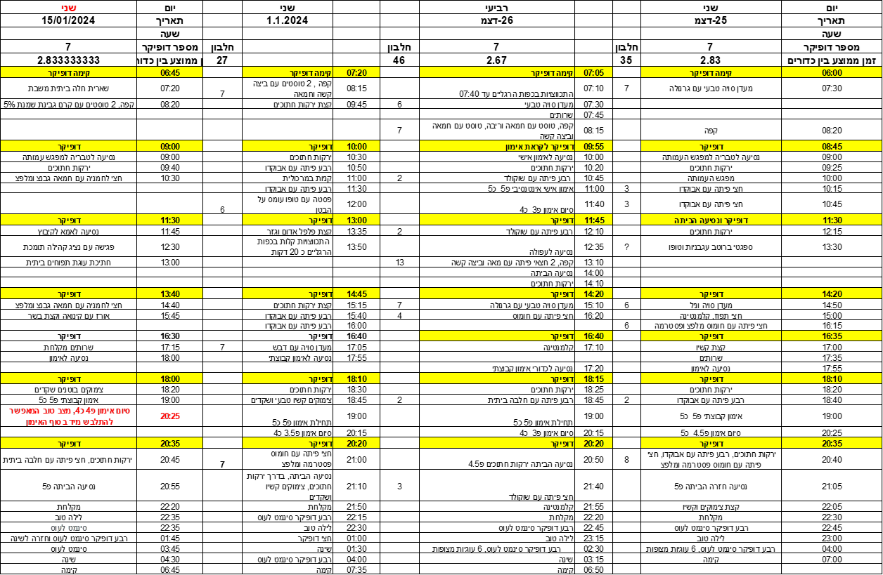

**Figure** **1:** Management of Parkinson's disease - Michael Jackont

Michael has experimented with various applications, both self-discovered and recommended (such as MyMovesMatter application) but found them unhelpful to the extent that he preferred to continue managing his schedule manually. In his view, these apps required him to "work" for them by entering data rather than serving as a user-friendly personal assistant that allowed him to gain insights about the information.

### 3.4 Existing Solutions

As a part of our development process, we have examined apps that respond to disease management. The objective of this review was to gather comprehensive information and gain a thorough understanding of what is suitable and unsuitable for individuals living with Parkinson's disease.

**strivePD** [19] was created in 2018 by RUNE LABS for Parkinson's patients. RUNE LABS is a group that includes doctors, software developers, and data analysts whose goal is to provide a deeper understanding of brain diseases, customized for each patient. At strivePD, they realized that there is a need to get information about several indices of Parkinson's patients: "About the length of the step, how severe is the tremor?", "When does the tremor get worse?", "When does the user feel that he is "OFF"?", "What is "OFF" for a Parkinson's patient?". "Is it related to movement or is it related to another factor that affects the patient (psychological condition)?" "How are the patient's stools"? The doctors and developers on the development team have dedicated an area to the application of exercises such as yoga, stretching, and table tennis. The doctors have seen a positive effect of the exercises on Parkinson's patients, and they are interested in more Parkinson's patients taking part and exercising. The **strivePD** app currently only works on iPhone devices and uses an Apple watch to receive data from the Parkinson's index. Parkinson's sufferers can enter data through voice recordings or by pressing a button for a specific task. The data taken from the Apple watch are tremors and measures of physical activity. **strivePD** is divided into two parts; the first part is for clinical users such as doctors, dieticians, and physiotherapists, and the other part is for Parkinson's patients. The part for the client users is online and contains graphics with the requested indicators. It is intended for the purpose of monitoring and adjusting the treatment so that it suits the Parkinson's contender in the best way. The part of the application, together with the Apple Watch, is designed to receive data from the Parkinson's patient user. The app is available in the US only and is supported by Apple products only (see Figures 2 and 3).

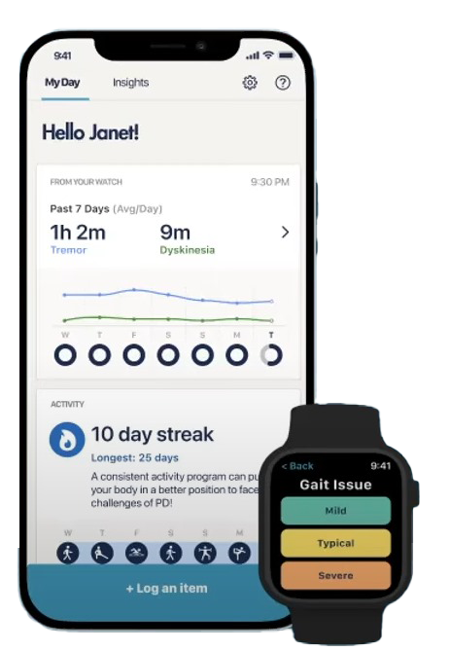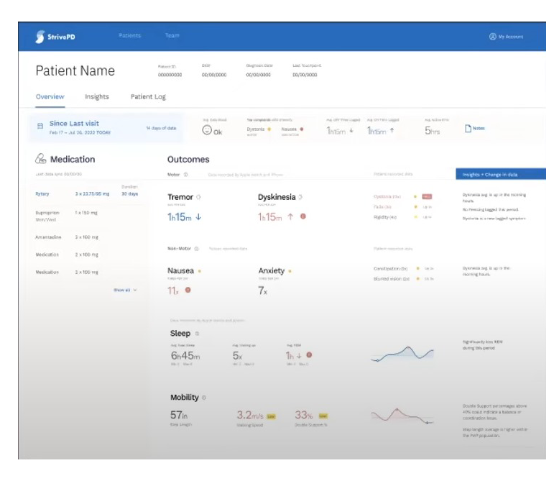

**Figure** **3**: StrivePD Web view of all collected data from patient used by healthcare specialists.

**Figure** **2**: StrivePD Application main screen and Apple Watch used to collect symptoms from PD patient.

**MyTherapy** [20]is an app for managing patient health, focusing on medication intake and activity logging. It assists patients with chronic or short-term diseases who face memory challenges due to cognitive or mental conditions. The app sends reminders at user-defined times for taking medicine, allows specification of medicine type (liquid, tablet) and amount, verifies medication intake through notifications, manages medicine stock, and reminds users to replenish supplies. MyTherapy enables users to set appointment reminders and add doctor and pharmacy information. It allows manual input of health indices with date and time stamps for documentation and monitoring. These indices include blood pressure, weight, blood sugar, body temperature, activities (like eating, shaving, cycling), and mood (with 5 optional modes available). (see Figures 4 and 5)

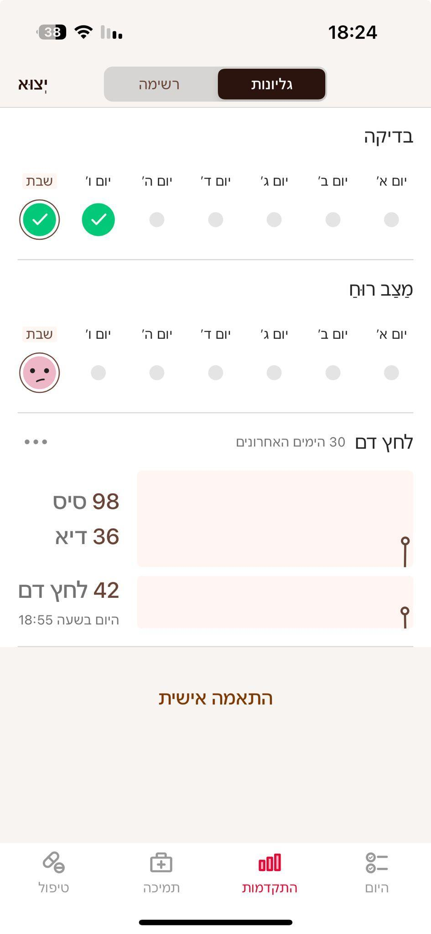

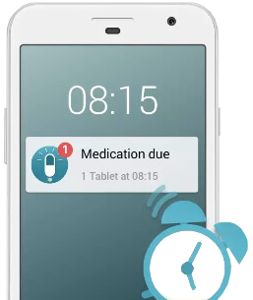

**Figure 5**: MyTherapy application.

**Figure** **4**: medicine notification - user phone.

**MyMovesMatter** [21] is an app founded by Richell Flanagan, who has Parkinson's disease. The co-founder observed from personal experience that the public perception of Parkinson's didn't align with reality. In fact, about 40 percent of people worldwide dealing with Parkinson's are women. Women typically face longer diagnosis times compared to men, and there's a lack of clinical guidance on adjusting medications to hormonal fluctuations. The co-founder also noted that women experience more severe side effects from Parkinson's medications than men. These insights were based on research conducted by the app's developers. The app is specifically tailored for women with Parkinson's disease. MyMovesMatter provides insights from patterns that can improve a Parkinson's patient's abilities and allows users to set medication reminders. The app's features include tracking symptoms, medication intake, menstrual cycles, and the ability to add voice notes, text, images, or videos. There's also a screen displaying a summary of all collected data. (see Figures 6, 7 and 8)

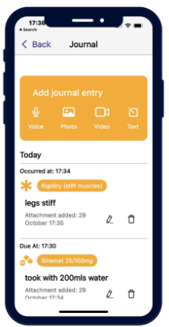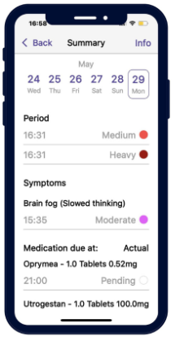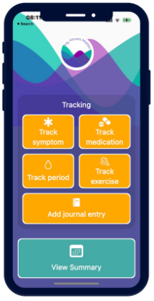

**Figure 7:** view summary screen.

**Figure 8:** MyMoveMatter add journal entry - insert event with the option: voice, photo, video and text.

**Figure 6:** MyMoveMetter main screen.

A summary of the three apps designed for Parkinson's contenders:

|  |  |  |
| --- | --- | --- |
|  | **Advantages** | **Disadvantages** |
| **StrivePD** | 1. Allows detailed logging of symptoms. 2. Helps track and remind about medication schedules. 3. Offers visual reports and trends over time. 4. Intuitive and easy to navigate. 5. Collecting data such as tremors and moving with Apple Watch in passive mode. 6. There is a separation between the Parkinson's patient and the clinical users. 7. Gathering all patient indices in easy-to-read graphs on the clinical user web. 8. Logging activity by speaking to Siri (private digital assistant in Apple products). 9. Reminds and recommends physical activity. | 1. Not integrated with all wearable devices. 2. Only usable on iOS devices. 3. Only available in the USA. 4. No option to picture the patient's food. |
| **MyTherapy** | 1. Remind about medication schedules. 2. Available to all users worldwide and also on IOS and Android mobile operating systems. 3. Ensures a patient's medication is taken using notification to approve. 4. Logging activity by choosing the correct buttons that describe the activity. | 1. Not a user centered design - need to learn how to work with the app. 2. Buttons are small for Parkinson's patients. 3. Does not display easy-to-read graphs. 4. MyTherapy does not integrate with clinical staff. |
| **MyMovesMatter** | 1. Entering and reporting events quickly using two buttons. 2. Reporting activity in the “add journal entry” button with a voice message, video, picture and text message. 3. For the women, there is an option to track the period. 4. Large buttons. 5. Available to all users worldwide and also on IOS and Android mobile operating systems. 6. Managing and tracking medicine. | 1. The medication tracking feature does not allow for dynamic time settings. 2. MyMovesMatter does not include features for managing the diet of Parkinson's patients. 3. MyMovesMatter lacks a graphical representation showing the chronological order of the patient's Parkinson's disease events. 4. MyMovesMatter does not integrate with clinical staff. |

By analyzing existing market solutions and incorporating their best features, we seek to create a user-friendly platform that offers a comprehensive and tailored experience. Our goal is to provide enhanced support and accessibility for Parkinson's patients, ultimately improving their quality of life through our CareHub application.

3.5 Summary

Applications should allow users to customize various settings to their individual needs and preferences, such as adjustments for text size, voice output settings, and visual theme options. Applications should incorporate accessibility features, such as suggested options or drop downs. They should feature interactive elements, schedule reminders, and notifications to engage with the user. Software should integrate tools for measuring and recording user progress, such as detailed progress logs or achievement markers. Applications should have a straightforward and easily comprehensible interface that Parkinson's patients can use easily. Additionally, the software should operate in the background with minimal user input required, benefiting individuals with Parkinson's disease.

4. Expected Achievement

The primary goal of this project is to develop an extensive, user-friendly smartphone application tailored specifically for individuals with Parkinson's disease (PD). This app aims to improve the quality of life for PD patients significantly. Our solution will help patients, relatives, and health staff by providing data and relevant information in real-time. The output will be a detailed value combining patients' daily schedule, nutrition menu, overall feeling during the day, and ON and OFF states. The app will provide an intuitive interface for patients to log and monitor their symptoms over time, including trembling, stiffness, and balance issues. By achieving these goals, the app is expected to empower PD patients with greater control over their condition, improve treatment outcomes, and enhance overall quality of life. It aims to serve as a comprehensive, portable support system that adapts to the individual needs of each user throughout their journey with Parkinson's disease.

The success criterion for our project will be:

1. CareHub will enable users to gain valuable insights from aggregated data on Parkinson's patients.
2. Parkinson's patients can efficiently input activity data to the CareHub application.
3. CareHub will be an application designed to become an essential tool in the daily life of individuals living with Parkinson's disease.

5. Research and Engineering Process

5.1 Process

Our process began with a crucial meeting with Michael Jackont, a Parkinson's patient who approached Braude College with a specific request for specialized software. During this meeting, Michael provided valuable insights into his needs and expectations for the application. He demonstrated his current method of managing his schedule using Google Tasks and presented a simple prototype of his envisioned app screens. This firsthand information from an end-user demonstrates crucial in shaping our understanding of the practical requirements.

Recognizing the multifaceted nature of Parkinson's care, we extended our research to include key individuals in Michael's support network. We met with:

* Shimi, Michael's table-tennis trainer, expressed a need to assess Michael's condition before each training session to tailor the exercises appropriately.
* Dana, Michael's nutritionist, highlighted the importance of tracking his diet, digestion, and overall well-being to provide targeted nutritional advice.
* Rachel, Michael's therapist, emphasized the need to monitor muscle sensitivity and condition to manage the disease progression effectively.

These meetings with Michael and his care team provided us with an extensive understanding of the diverse needs that our application must address. By gathering this important and necessary information, we are now well-positioned to develop an application that will truly suit the needs of Parkinson's patients, offering a tool that supports both the individuals living with the condition and their care providers.

We used a user-centered design (UCD) approach, focusing on real-world needs and experiences, to set a strong foundation for developing an application that can make a meaningful difference in the lives of those managing Parkinson's disease. As part of the UCD approach, we used the concept of “persona”, originally introduced by Cooper ‎[1999], for our end-users to gather their requirements:

|  |  |
| --- | --- |
| **Michael** | Name |
| Parkinson's patient | Role |
| Michael is an active Parkinson's patient who takes a hands-on approach to managing his condition. He's comfortable with technology and sees its potential to improve his well-being. Michael experiences emotional instability, feeling highs before important events and lows afterward. He manages his stress by staying active and needs to be mindful of his diet. | General description |
| Michael's primary goal is to improve his overall health and quality of life. He wants to extend the periods when his Parkinson's symptoms are under control ("on" periods) and minimize those when they worsen ("off" periods). Tracking his progress and identifying patterns in his condition is important to him. Maintaining a routine and staying motivated are also components of his daily life. | Goals |
| 1. The application should be user-friendly and minimize the need for manual data entry through features like voice commands and advanced options. 2. Reminders for medication and food intake that are tailored to his specific needs. 3. Additionally, he wants personalized insights based on collected data, such as how food choices affect his mood or how exercise impacts the effectiveness of his medication. 4. Data visualization tools would be helpful for Michael to see trends and improvements over time. 5. Integration with his healthcare team, including a dietician and neurologist. 6. The application should offer communication tools that he can use during "off" periods when his motor and cognitive abilities are limited. | Needs |
| Michael gets up at 7 a.m. in the morning and gets ready for his day. At 8 a.m. CareHub reminds him to prepare his breakfast so that at exactly 8:30 he can eat it according to the schedule, and reminds him to take his specific pills and drink water. At 8:30 he gets a reminder to eat breakfast and drink water. CareHub reminds Michael that he practices table tennis at 9 a.m. in the sports hall of the Kadoorie school, and in addition, asks Michael how he feels that day so that Shimi can observe this figure and tailor a workout specifically for him. At 11 a.m. Michael takes a drink break and also eats nuts. Michael comes home from training at 12 p.m. and the app reminds him to prepare his lunch so he can eat right on time. At 1 p.m., the app reminds him to eat lunch and drink water. The app also asks him how he felt during the day and whether he took another pill. | Scenario |

|  |  |
| --- | --- |
| **Dana** | Name |
| Michael's dietician | Role |
| Dana is a registered dietician who works with Parkinson's patients like Michael. She recognizes the importance of nutrition in managing disease and improving patients' overall well-being. However, she's aware that many Parkinson's patients lack awareness of the impact of food on their condition. Dana is committed to creating a patient-centered approach to nutrition and uses various communication methods to cater to patients with different needs and abilities. | General description |
| Dana's primary goal is to help patients like Michael understand the connection between nutrition and their Parkinson's symptoms. She aims to create a unified platform that connects all healthcare professionals involved in a patient's care, allowing for a more collaborative approach to managing the disease. Additionally, she wants to encourage consistent use of the application by making it accessible and user-friendly for patients of all ages and backgrounds. | Goals |
| 1. The app should be easy for patients to use and track their food intake. 2. The app should analyze food intake and offer personalized recommendations. 3. Track guts movements. 4. Hunger levels. | Needs |
| The CareHub app supports Dana, Michael's dietitian, in her weekly nutritional assessment and planning for Michael's Parkinson's management. It allows her to review comprehensive data and provide tailored recommendations during their scheduled appointment.  On Tuesday at 2 pm, Dana logs into the CareHub app for her weekly appointment with Michael. She begins by reviewing the past week's nutritional data collected by the app. Dana examines Michael's daily food logs, noting the types and quantities of food consumed and their timing in relation to his medication schedule. Dana analyzes the nutritional values ​​of the food Michael ate throughout the week and examines the stools and their quality. She correlates this nutritional data with Michael's logged energy levels and reported "on" and "off" periods. Using CareHub's analysis tools, Dana identifies patterns between Michael's diet and his symptom management on CareHub. Based on the collected data review and Michael's feelings, she formulates adjusted dietary recommendations for the coming week. | Scenario |

|  |  |
| --- | --- |
| **Shimi** | Name |
| Table Tennis Coach | Role |
| Shimi is a dedicated table tennis coach passionate about helping people with Parkinson's disease. At first, he was skeptical about training Parkinson's patients, but he now sees his role as a mission and takes great satisfaction in pushing his trainees and seeing them improve. Through training, Shimi developed the ability to assess a patient's Parkinson's condition based on their movements and how they hold the equipment. | General description |
| Shimi's goals are all centered around empowering his students and improving their quality of life through sports training. He wants to help them manage their Parkinson's symptoms and experience an overall improvement in well-being. | Goals |
| To empower his students and personalize their training experience,   * + - 1. Shimi needs the application to be a data hub.       2. The system should collect and analyze data on the trainees' Parkinson's condition and training performance.       3. With access to this information (with patient permission), Shimi can tailor training plans, track progress, support consistent exercise routines, and even get insights into potentially disruptive foods in a trainee's diet. Ultimately, the application should give Shimi the tools to optimize training and monitor the effectiveness of his coaching in improving his trainees' well-being. | Needs |
| Shimi, the table tennis coach, wants to know - before the training - Michael's Parkinson's level and physical ability level in order to know how to adjust a training session for him that day. The app will alert Shimi about Michael's condition as he entered the app earlier at 9 am, about half an hour before the start of training. | Scenario |

|  |  |
| --- | --- |
| **Rachel** | Name |
| Physiotherapist | Role |
| Rachel is a physiotherapist who works with Parkinson's patients. She is focused on understanding and treating pain associated with the condition. Rachel observes that patients often struggle to recall details from their previous visits due to memory limitations or an "OFF" period. | General description |
| Rachel, a physiotherapist, prioritizes reducing pain in Parkinson's patients. She also strives to improve their function and mobility for a more independent life. To achieve these goals, Rachel seeks a data-driven approach to physiotherapy that overcomes memory limitations. | Goals |
| Rachel needs the application to be a data hub. It should collect details on pain location, intensity, and triggers, even during "off" periods. Additionally, features for tracking movement range, functional abilities, food intake, and activity levels. Ultimately, Rachel needs the app to give her a comprehensive picture of each patient for data-driven treatment plans. | Needs |
| On Thursday at 3 pm, Rachel opens the CareHub app to prepare for her weekly session with Michael. She begins by reviewing the past week's data, focusing on Michael's daily physical activities and reported pain levels. She pays close attention to any reported difficulties with specific movements or activities of daily living, such as getting in and out of a car or putting on shoes. She also reviews Michael's medication schedule and its correlation with his physical performance and pain levels throughout the week. Using CareHub's analysis tools, she identifies patterns between Michael's physical activities, pain reports, and overall Parkinson's symptoms. After reviewing the data received from CareHub and Michael's personal feelings, Rachel focuses and performs targeted physical therapy exercises to improve movement and pain. | Scenario |

The concept of "persona" helped us define our end-users and gather their requirements. We defined an end-user for a Parkinson's patient parent and his caregiver. The patient aims to manage his activity data to improve the quality of his daily life, while the companion simply hopes to help him do so. Hence, the application's main users and functionality are presented in the following Use Case diagram (see Figure 11).

**The main requirements for our system:**

Functional Requirements:

1. The system allows PD patients to enter nutrition intake data.
2. The system allows PD patients to log physical activities.
3. The system allows PD patients to record food intake.
4. The system allows PD patients to capture and upload food pictures.
5. The system allows PD patients to log their symptoms.
6. The system allows PD patients to rate their overall feeling.
7. The system allows new users to sign up and create an account.
8. The system allows registered users to login.
9. The system allows users to set their roles (PD Patient or Caregiver).
10. The system allows displaying requested data in graphical format.
11. The system allows users to view patient data.
12. The system allows users to edit or correct previously entered data.

Non-Functional Requirements:

1. The system should be designed with an intuitive interface suitable for users with motor disabilities.
2. The system should minimize required scrolling across screens.
3. The system should be usable by individuals of various age groups and technical proficiencies.
4. The system should employ a user-centric approach, integrating seamlessly into the user's daily routine.
5. The system should require minimal effort to operate.
6. The system should present data in a way that helps PD patients better organize their day and increase "ON" states.
7. The system should be available for use most of the time, excluding scheduled maintenance.
8. The system should adjust to relevant healthcare data protection regulations to protect user data.
9. The system should be designed for easy maintenance and cost-effective operations.
10. The system should be designed to allow the future addition of new data entry methods (photo logging).
11. The system should be easy to maintain and cost-effective.

After defining the system's requirements, we revisited our clients to ensure our design met their needs. Following an analysis of existing market solutions (see Chapter 3), we planned the system's functionality and identified the need to build two modules: Input and Output. During this phase, we also created our Use-Case diagram (see Chapter 5). With most of the system information gathered, we designed the prototype and prepared testing plans.

Throughout the semester, as we advanced in our project, we encountered several challenges in developing a cross-platform application, including:

Learning new software environments and programming languages:

* Web development: Frontend with React and backend with ExpressJS, both popular JavaScript libraries.
* MERN stack: Utilizing MongoDB, ExpressJS, React, and Node.js (see Figure 10).
* Google Sign-In services: Implementing secure user sign-up.
* NoSQL database: Integration and management.
* Understanding the needs of people with motor disabilities: Researching theory to better tailor the application to their requirements.

In the upcoming phases of development, we will address these challenges and begin coding our software according to the established plans and models, progressing step by step.

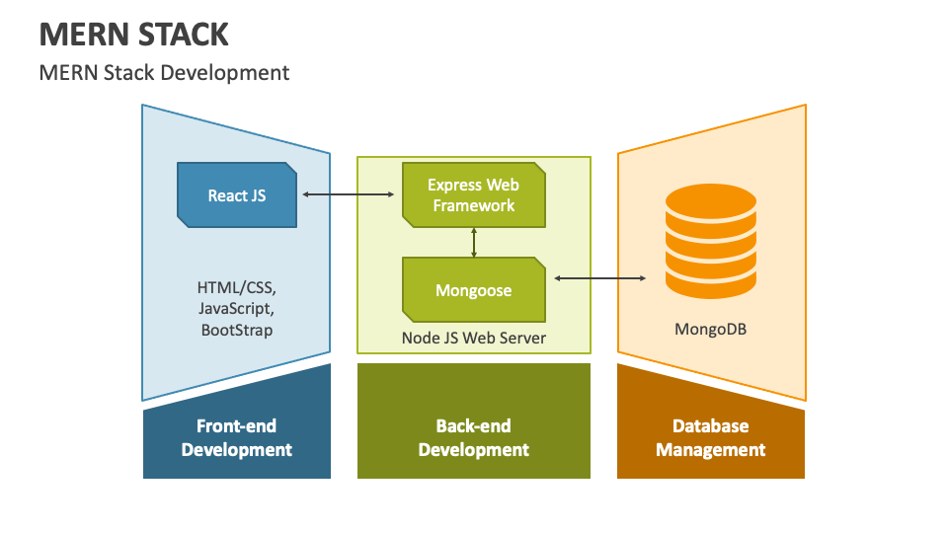

**Figure 10:** Application Architecture.

5.2 Product

Our system is a web application solution that will help PD patients efficiently manage their day and maintain "ON" states as long as possible. In the following sections, we will describe the core components of our product.

6. Diagrams

6.1 Use Case

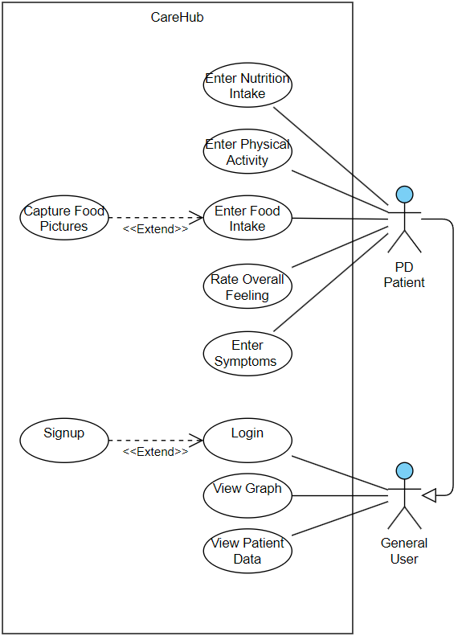

**Figure 11:** Use Case.

|  |  |
| --- | --- |
| Use Case | Enter Nutrition Intake |
| Description | The actor enters information about their nutritional intake |
| Actors | PD Patient |
| Triggers | The actor selects "Enter Nutrition Intake" option |
| Initial Conditions | User is logged in |
| Successful Scenario | 1. The actor selects "Enter Nutrition Intake" 2. The system displays nutrition entry form 3. The actor inputs nutrition details 4. The system saves the entered data |
| Alternative Scenario | 1. Actor leaves some fields empty 2. System prompts to fill required fields |

|  |  |
| --- | --- |
| Use Case | Enter Physical Activity |
| Description | The actor logs their physical activities |
| Actors | PD Patient |
| Triggers | The actor selects "Enter Physical Activity" option |
| Initial Conditions | User is logged in |
| Successful Scenario | 1. The actor selects "Enter Physical Activity" 2. The system displays activity entry form 3. The actor inputs activity details (type, duration, intensity) 4. The system saves the entered data |
| Alternative Scenario | 1. Actor wants to log multiple activities 2. System allows adding multiple entries |

|  |  |
| --- | --- |
| Use Case | Enter Food Intake |
| Description | The actor enters information about food consumed |
| Actors | PD Patient |
| Triggers | The actor selects "Enter Food Intake" option |
| Initial Conditions | User is logged in |
| Successful Scenario | 1. The actor selects "Enter Food Intake" 2. The system displays food entry form 3. The actor inputs food details 4. The system saves the entered data |
| Alternative Scenario | 1. Actor uses "Capture Food Pictures" to address the food consumed 2. System saves the entered picture |

|  |  |
| --- | --- |
| Use Case | Capture Food Pictures |
| Description | The actor takes pictures of their food to assist in food intake logging |
| Actors | PD Patient |
| Triggers | The actor selects "Capture Food Pictures" option |
| Initial Conditions | User is logged in, device has camera access |
| Successful Scenario | 1. The actor selects "Capture Food Pictures" 2. The system opens camera interface 3. The actor takes a picture of their food 4. The system processes the image and suggests food items |
| Alternative Scenario | 1. Camera access is denied 2. System prompts for camera permissions |

|  |  |
| --- | --- |
| Use Case | Rate Overall Feeling |
| Description | The actor rates their overall feeling or well-being throughout the day |
| Actors | PD Patient |
| Triggers | The actor selects "Rate Overall Feeling" option |
| Initial Conditions | User is logged in |
| Successful Scenario | 1. The actor selects "Rate Overall Feeling" 2. The system displays a rating scale (scale 1-5, emoji-based) 3. The actor selects their current overall feeling 4. The system saves the rating |
| Alternative Scenario | 1. Actor wants to add comments to their rating 2. System provides an optional text field for additional notes |

|  |  |
| --- | --- |
| Use Case | Enter Symptoms |
| Description | The actor logs their PD symptoms |
| Actors | PD Patient |
| Triggers | The actor selects "Enter Symptoms" option |
| Initial Conditions | User is logged in, device has camera access |
| Successful Scenario | 1. The actor selects "Enter Symptoms" 2. The system displays known symptoms to choose 3. The actor inputs symptom details (time, severity, duration) 4. The system saves the entered data |
| Alternative Scenario | 1. Actor reports a new symptom not in the list 2. System allows free-text entry for new symptoms |

|  |  |
| --- | --- |
| Use Case | Login |
| Description | Registered user accesses their account |
| Actors | General User, PD Patient |
| Triggers | User selects "Login" option |
| Initial Conditions | User is not logged in |
| Successful Scenario | 1. User selects "Login" 2. System displays login form 3. User enters credentials 4. System validates credentials 5. System logs user in |
| Alternative Scenario | 1. User enters incorrect credentials 2. System displays error message |

|  |  |
| --- | --- |
| Use Case | Signup |
| Description | New user creates an account |
| Actors | General User |
| Triggers | User selects "Signup" option |
| Initial Conditions | User is not exist |
| Successful Scenario | 1. User selects "Signup" 2. System displays signup form 3. User enters required information 4. User selects appropriate role 5. System validates information 6. System creates account and logs user in |
| Alternative Scenario | 1. User enters invalid information 2. System displays error and asks for correction |

|  |  |
| --- | --- |
| Use Case | View Graph |
| Description | The actor checks the daily graph for overview |
| Actors | General User, PD Patient |
| Triggers | The actors press the “View Graph” button |
| Initial Conditions | Data entered throughout the day |
| Successful Scenario | 1. The actors click on ‘Daily Graph’ button 2. The system opens the ‘Daily Graph’ overview 3. The system shows the daily data on a graph |
| Alternative Scenario | 1. No data available for the day 2. System displays a message indicating no data to show |

|  |  |
| --- | --- |
| Use Case | View Patient Data |
| Description | Caregiver views data of associated PD Patient |
| Actors | General User, PD Patient |
| Triggers | Caregiver selects "View Patient Data" option |
| Initial Conditions | User is logged in as PD Patient or a caregiver (General User) and associated with a PD Patient |
| Successful Scenario | 1. Caregiver selects "View Patient Data" 2. System displays patient's data overview 3. Caregiver can navigate through different data categories |
| Alternative Scenario | 1. No patient associated with caregiver 2. System prompts to associate with a patient first |

6.2 GUI prototype

The flowchart illustrates the process for managing and analyzing data logged by Parkinson's patients in the app. It begins with the patient logging an event, such as symptoms or daily activities. The system allows the patient or authorized caregiver to view the data if an event is logged. If no new event is logged, the system checks if there are previous reports available. If past reports exist, these can also be viewed. The flow then checks if the caregiver has viewing permissions; if granted, the caregiver can access insights derived from the patient's data. The process then concludes, ensuring that patients and caregivers have timely and secure access to vital information supporting ongoing care and monitoring.

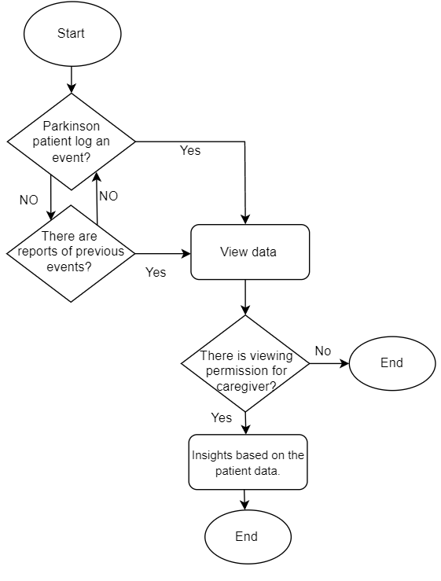

**Figure 9:** Flow Chart of actions in CareHub system.

**Main screens of the suggested system:**

1. **Welcome screen and login to CareHub (PD Patient/Caregiver):** The screen is displayed at entrance to CareHub app. The user is required to enter his Email and password. Clicking on the “Login” button will allow him to access the home page after verifying your credentials. New users will click the "Signup" button, directing them to a registration screen to create an account.

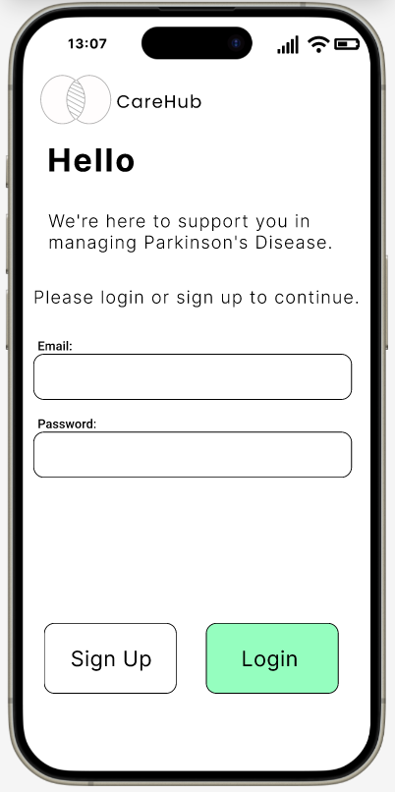

1. **Signup screen creates a new account (PD Patient/Caregiver):** On the signup screen, fill in your personal information in the given fields, pick a strong password, and choose your role as either a PD Patient or a Caregiver using the segmented button.

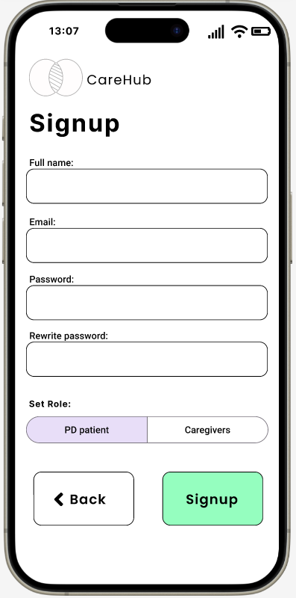

1. **Home Screen** **(PD Patient):**

After pressing the “Login” button on the welcome and login screen, you'll see the main display. Here, the user can log their activities into CareHub.

* Pressing the “Symptoms” button takes you to the “Insert Symptoms” screen.
* Pressing the “Medicine” button takes you to the “Insert Medicine” screen.
* Pressing the “Nutrition” button takes you to the “Insert Nutrition” screen.
* Pressing the “Training” button takes you to the “Insert Training” screen.

At the bottom, there’s a menu with a "Home" button, a "View Data" button, and a "Settings" button. The current screen is highlighted in green in the menu.  
In the "Settings" section, the user can add or update their caregiver and personal information.

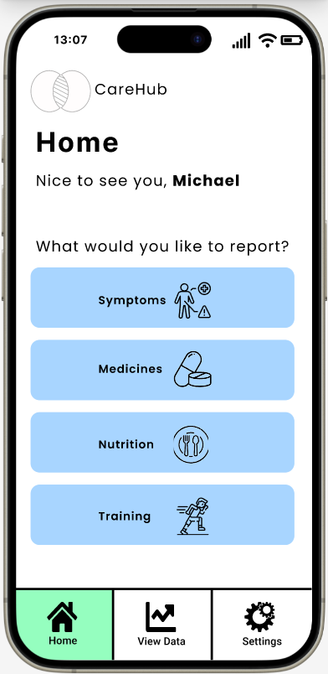

1. **Insert Symptoms screen** **(PD Patient):**

On this screen, the user selects the symptom they want to report to CareHub. After choosing a symptom, they are directed to the “Symptom Report” screen.

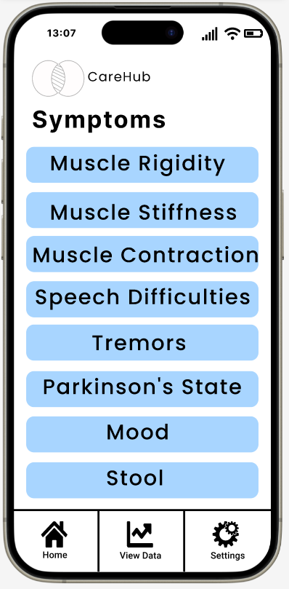

1. **Symptom report screen** **(PD Patient):**

On this screen, the user reports a specific symptom. They can set the symptom's time to the current time or choose a different one. In the “Severity” section, the user rates the symptom from 1 star to 5 stars, with (1) being the worst and (5) being the best. In the “Comment” section, users can add extra details. Pressing the “Add” button will save the symptom to the CareHub system.

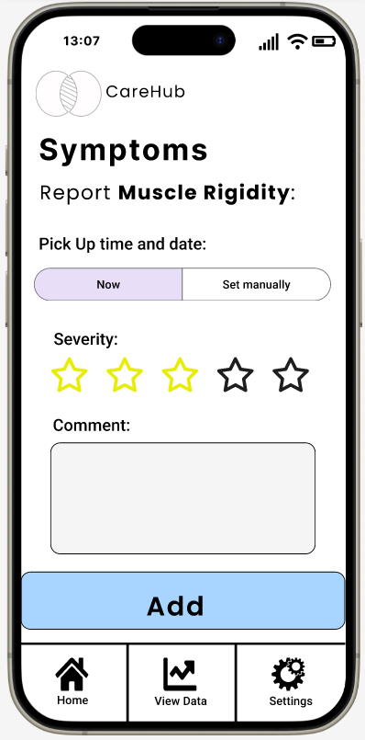

1. **Insert Medicine screen (PD Patient):**

After pressing the “Medicines” button from the homepage, the user will be directed to this screen to report the medicine they’ve taken.

* In the “Medicine Name” text box, the user will enter the name of the medicine.
* The “Medicine Taken” button allows the user to set the time and date.
* The user will choose how the medicine was taken — either as “Liquid” or “Pill”—using the segmented button.
* After selecting the method, the user will choose the dose amount.
* Finally, pressing the “Add” button will save the medicine information to the CareHub database.

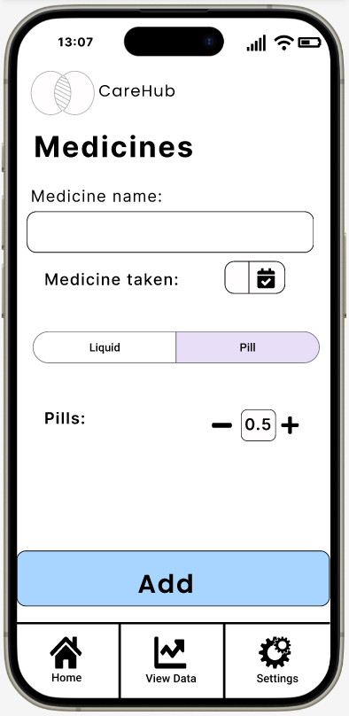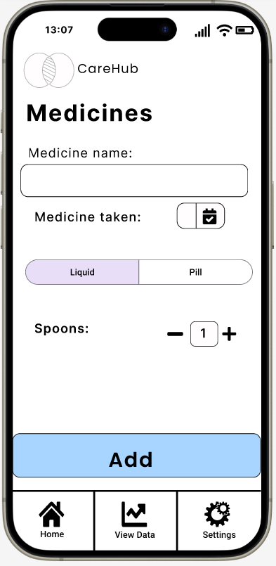

1. **Insert Nutrition screen (PD patient):**

After pressing the “Nutrition” button from the homepage, the user will be directed to this screen to report their nutrition intake.

* In the “Food Name” field, the user enters the name of the food. If the food is already in the database, the name will autocomplete.
* The “Food Taken” button allows the user to set the time and date.
* By selecting “Take a Picture,” the user can use their phone's camera to add a photo of the food.
* The “Nutritional Values” table displays the nutritional details. If any cell is empty, indicating missing information, the user can click on it to enter the necessary data. All information added to the table is automatically saved to the database.
* Pressing the “Add” button will save the nutrition details to the CareHub database.

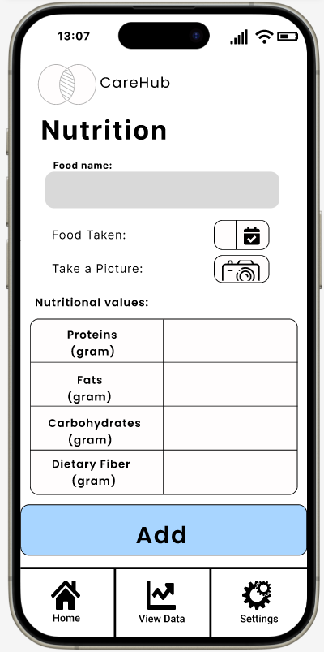

1. **Setting screen (PD patient):**

Accessing the "Settings" option from the bottom menu lets you add caregivers to your account. The user will fill in the caregiver’s information in the “Caregiver Name,” “Profession,” and “Email” fields.

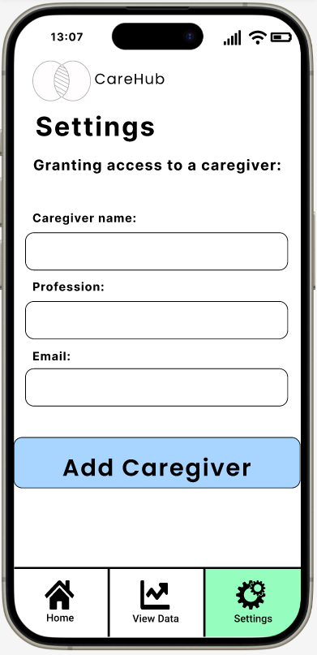

1. **Home Screen** **(Caregiver):**

After logging into CareHub, the caregiver will select a specific client from the “Choose Client” dropdown list. In the view section, the caregiver can choose a time range to see the patient's events. Pressing on the range will direct them to the graph screen.

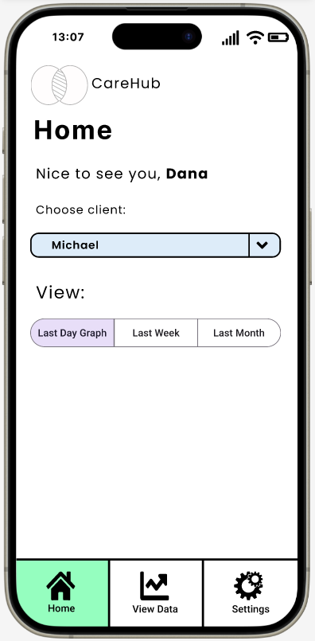

1. **PD patient graph** **(Caregiver):**

The screen shows all patient activities based on the selected time range. The graph for Parkinson's patients features an X-axis for time and a Y-axis for the severity of Parkinson's, ranging from 1 to 5. Vertical dotted lines on the graph mark individual patient activities.

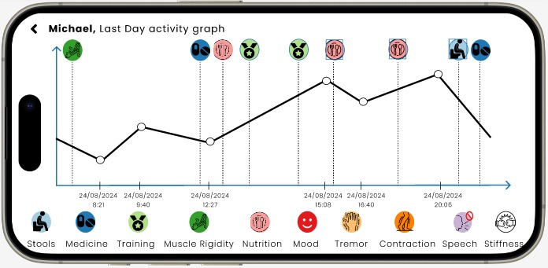

7. Evaluation / Verification Plan

To ensure the system operates correctly and as intended, we will evaluate it through the following steps:

1. Execute the testing plan.
2. Have the system used by two representative users: a caregiver and a patient.

7.1 Testing Plan

To ensure the reliability of our final product, we have developed a testing plan, which is detailed in the table below. This plan is based on the Use Case descriptions we created and the GUI screens, allowing us to identify potential problematic scenarios, weaknesses, and processes requiring accuracy verification.

|  |  |  |  |
| --- | --- | --- | --- |
| **#** | **Test Subject** | **Test Headline** | **Expected Result** |
| **1** | User Registration | New user signup with valid information | User account is created successfully and user is redirected to login page |
| Attempt to sign up with an existing email | System displays an error message indicating the email is already in use |
| **2** | User Authentication | Existing user login with correct information | User is logged in and directed to their dashboard |
| Login with incorrect password | System displays an error message and prevents login |
| **3** | Role Selection | User selects role as PD Patient | User profile is updated with PD Patient role and relevant features are accessible |
| Set user role as Caregiver | User profile is updated with Caregiver role and relevant features are accessible |
| **4** | Nutrition Intake | PD Patient enters daily nutrition data | Nutrition data is saved and reflected in the patient's health record |
| **5** | Physical Activity | PD Patient logs a new physical activity | Activity is recorded and added to the patient's exercise log |
| **6** | Food Intake | PD Patient records food intake for a meal | Food intake is saved and updated in the patient's dietary log |
| **7** | Food Picture Upload | PD Patient captures and uploads a food picture | Picture is successfully uploaded and associated with the corresponding meal entry |
| **8** | Symptom Logging | PD Patient logs current symptoms | Symptoms are recorded and added to the patient's health timeline |
| **9** | Overall Feeling Rating | PD Patient rates their overall feeling for the day | Rating is saved and reflected in the patient's daily health summary |
| **10** | Data Visualization | User requests to view health data in graph format | Accurate graphical representation of requested data is displayed |
| **11** | Patient Data View | User accesses patient data | Patient's health data is displayed in a extensive and organized way |
| **12** | Data Correction | User edits previously entered data | Data is successfully updated and reflected in all relevant sections including database |
| **13** | Accessibility | Navigate through app using only mouse or finger (touch screen) | All features are accessible and operable without using keyboard |
| **14** | Performance | Load patient dashboard | Dashboard loads within 3 seconds on a standard internet connection |
| **15** | Data Protection (Security) | Attempt to access patient data without authorization | Access is denied and security measures are triggered |
| **16** | Error Handling | Enter invalid data in a form field | Clear error message is displayed and form is not submitted |
| **17** | Responsiveness | Access application on mobile device | Interface adapts to screen size without loss of functionality |
| **18** | Data Consistency | Enter data and view it across different pages | Entered data is consistently displayed across all relevant sections of the app |
| **19** | User Interface | Evaluate scrolling requirement on main pages | Minimal scrolling required on desktop and mobile interfaces |
| **20** | Integration | Connect with Google Sign-In | User can successfully sign up and log in using their Google account |

7.2 Evaluation by User

We will conduct user evaluations with two types of users to assess the effectiveness and usability of the CareHub system: a PD Patient and a caregiver.

PD Patient Evaluation:

We will ask the PD patient to perform two key tasks:

* Locate and select their profile picture on the screen.
* Enter daily symptom information using the system's input methods.

We will then collect feedback on:

* Ease of use, particularly considering motor symptoms.
* Clarity of instructions and interface elements.
* Comfort level with using the system independently.

Caregiver Evaluation:

We will ask the caregiver to perform several tasks within the system:

* Complete data collection using the system's features.
* Analyze reports on patient data and a graph.

After these tasks, we will gather feedback on the following aspects:

* Overall user experience and interface design.
* Clarity and intuitiveness of system navigation and usage.
* The system's effectiveness in streamlining their workflow.
* The relevance and format of generated reports.

This evaluation process will provide valuable insights into the system's usability for both caregivers and patients, helping us identify areas for improvement and ensure that CareHub meets the needs of all its intended users.

References

1. Kalia, L. V., & Lang, A. E. (2015). Parkinson's disease. The Lancet, 386(9996), 896-912.
2. Dorsey, E. A., Constantinescu, R., Thompson, J. P., Biglan, K. M., Holloway, R. G., Kieburtz, K., ... & Tanner, C. M. (2007). Projected number of people with Parkinson disease in the most populous nations, 2005 through 2030. Neurology, 68(5), 384-386.
3. Mak, M. K., Wong-Yu, I. S., Shen, X., & Chung, C. L. (2017). Long-term effects of exercise and physical therapy in people with Parkinson disease. Nature Reviews Neurology, 13(11), 689-703.
4. Ongun, N. (2018). Does nutritional status affect Parkinson's Disease features and quality of life?. PLoS One, 13(10), e0205100.
5. Goetz, C. G. (2011). The history of Parkinson's disease: Early clinical descriptions and neurological therapies. Cold Spring Harbor Perspectives in Medicine, 1(1), a008862.
6. van der Kolk, N. M., & King, L. A. (2013). Effects of exercise on mobility in people with Parkinson's disease. Movement Disorders, 28(11), 1386-1396.
7. Chaudhuri, K. R., & Schapira, A. H. (2009). Non-motor symptoms of Parkinson’s disease: Dopaminergic pathophysiology and treatment. Lancet Neurology, 8(5), 464-474.
8. Schrag, A., Jahanshahi, M., & Quinn, N. (2000). What contributes to quality of life in patients with Parkinson's disease? Journal of Neurology, Neurosurgery & Psychiatry, 69(3), 308-312.
9. Poewe, W., & Mahlknecht, P. (2009). The clinical progression of Parkinson’s disease. Parkinsonism & Related Disorders, 15(S3), S28-S32.
10. Grosset, K. A., Bone, I., & Grosset, D. G. (2009). Switching medication in Parkinson’s disease: Practical issues and management. Postgraduate Medical Journal, 85(1006), 622-628.
11. Goodwin, V. A., Richards, S. H., Taylor, R. S., Taylor, A. H., & Campbell, J. L. (2008). The effectiveness of exercise interventions for people with Parkinson's disease: A systematic review and meta-analysis. Movement Disorders, 23(5), 631-640.
12. Barichella, M., Cereda, E., Pezzoli, G., & Faierman, S. A. (2017). Diet and nutritional considerations in Parkinson's disease. Frontiers in Aging Neuroscience, 9, Article 80.
13. Pandey, S., & Bajaj, B. K. (2018). Sleep disorders in Parkinson's disease. Journal of Neurology, 265(4), 850-860.
14. Pickut, B. A., Vanneste, S., Hirsch, M. A., van Hecke, W., Kerckhofs, E., Marien, P., & Parizel, P. M. (2015). Mindfulness training among individuals with Parkinson's disease: Neurobehavioral effects. Parkinson's Disease, 2015, Article 816404.
15. Svenningsson, P., Westman, E., Ballard, C., & Aarsland, D. (2012). Cognitive impairment in patients with Parkinson's disease: diagnosis, biomarkers, and treatment. The Lancet Neurology, 11(8), 697-707.
16. Espay, A. J., Bonato, P., Nahab, F. B., Maetzler, W., Dean, J. M., Klucken, J., ... & Papapetropoulos, S. (2016). Technology in Parkinson's disease: Challenges and opportunities. Movement Disorders, 31(9), 1272-1282.
17. Armstrong, M. J., & Okun, M. S. (2020). Diagnosis and Treatment of Parkinson Disease: A Review. *JAMA, 323*(6), 548–560.
18. https://medium.com/@ashish-k-mishra/getting-started-with-mern-stack-building-your-first-web-application-0bbb6799d251
19. https://www.strive.group/
20. https://www.mytherapyapp.com/
21. https://www.mymovesmatter.com/get-the-app

**Appendix**

**Project Kick-off Meeting:**

Current state:

Michael meticulously tracks his daily activities using Google Tasks to identify effective and less effective strategies.

Requirements:

Maintain a work plan to preserve current routines.

Document daily activities to identify successful days and replicate their patterns.

Key Needs:

Data Collection and Preservation: Effectively capture and store relevant information.

Data Analysis: Analyze collected data to gain insights and identify patterns.

Additional Considerations:

Ease of Use:

* Implement simple button-based interactions to minimize text input challenges.

Utilize large buttons to accommodate potential tremors.

* Provide voice input options for added accessibility.
* Automatically record the current date and time to streamline data entry.

Emotional Well-being:

* Adding information about how I felt, not just a technical indication
* How I felt on a personal level and on a Parkinson's level
* Reminders
* Possibility of receiving funny/reinforcing feedback
* Something social and pleasant

Existing Market Solutions:

REMEPY: An Israeli startup developing a similar solution. Explore their website for more information.

**Summary of the first meeting:**

**Date:** May 1, 2024

**Location:** Braude, Karmiel

**Attendees:**

* Michael Jackont
* Dana Levin - Ashkenazi
* Yogev Katzir
* Julia Shaidin
* Omer Sommerstein
* Aviram Fishman
* Ornit Bar-Zaet

**Meeting Notes:**

* The app should be web-based to allow multiple users to access the collected data.
* Data visualization tools should be available for all users to extract relevant information.
* Stakeholders include the patient, spouse, caregiver, doctor, and dietician.
* All stakeholders should have access to all data, as all aspects of the patient's life are interconnected.
* It is crucial to observe and interact with other Parkinson's patients to gain insights into the diverse manifestations and functional variations of the disease.
* It is crucial to observe and interact with other Parkinson's patients to gain insights into the diverse manifestations and functional variations of the disease.
* Suggested future in-person meetings:
  + Tiberias: Parkinson's support group meeting, Mondays from 10:00 AM to 12:00 PM
  + Kaduri: Table tennis training, Sundays and Wednesdays from 10:00 AM to 12:00 PM
* Data entry should be efficient and user-friendly, avoiding time-consuming text input or recording. Options could include clicking on icons, selecting pre-populated options, and using voice commands.
* Research goals based on collected data:
  + Measuring the time it takes to transition from "off" to "on" states after medication intake
  + Determining the impact of exercise and nutrition on "on" state duration
  + Identifying optimal medication timing to prevent "off" states
* The app should integrate data input from caregivers (family members).
* A follow-up meeting will be held on Sunday, May 19th at 10:00 AM at Kaduri to observe a table tennis training session and discuss the app's development.
* Attendees at the follow-up meeting will include Michael, Dana vliron (dietician), Shimi (table tennis coordinator), and Chagit (Michael's wife).
* Prepare questions for each participant in addition to observation, such as:
  + What information does Dana (dietician) need to specify Michael's diet?
  + What areas does Shimi want to improve in Michael's training?
  + What are the goals of the training (e.g., improving posture, grip, overall well-being)?
  + How can the training be tailored to Michael's specific needs?

**Next Steps:**

* Continue developing the app based on the discussed requirements.
* Prepare for the follow-up meeting on May 19th.

**Summary of the second meeting:**

**Date:** May 19, 2024

**Location:** Kadoori (presumably a facility or location)

**Attendees:**

* Michael Jackont
* Dana Levin - Ashkenazi
* Shimi (table tennis coordinator)
* Nir (assistant coach)
* Rachel (physiotherapist)
* Guy Yochanan
* Aaron

**Meeting Objectives:**

* Observe additional Parkinson's patients (to see different levels of functioning)
* Interview other stakeholders in the system (coach, physiotherapist)
* Interview (if possible) additional patients

**General Impressions:**

* "I have Parkinson's in my life, but my life is not just Parkinson's" - a strong and accurate statement
* At first, it was very difficult for us to identify which of the participants had Parkinson's
* We were impressed (Rachel and Dana confirmed the impression) that there are more male patients than female patients.
* There is a disagreement between what patients say and what others say about them.
* The disease is very individual, there are similar characteristics, but there is also a lot of variation.
* There is a connection between the emotional state and the physical state.

**Interview with Rachel** (physiotherapist)**:**

* Currently, most patients do not remember everything that happened during the two weeks since the last visit, but only the things that happened in the last day or two.
* Sees the importance of developing an app of this type.
* Things that are important to her in the context of her work are:
  + Everything related to pain
    - Where does it hurt?
    - What is the level/intensity of the pain?
    - When does it hurt? Is it after treatment/exercise?
    - Is it due to a specific activity?
    - Has the pain improved/worsened over time?
  + Monitoring range of motion
    - Each patient has pain in a different place, so the questions are adapted to them specifically, a few examples:
      * Can they get in/out of a car? (when there is a knee problem)
      * Can they get dressed on their own? (when there is a problem with the shoulder)
      * Putting on shoes (when there is a problem with the feet)
      * Opening/closing a door
      * Opening/closing a bottle cap (when there is a problem with fine motor skills)
  + She said that it is possible to prepare a collection of questions for each part of the body
  + It is difficult to treat people when they are "off", because the body becomes rigid, so your requirement from the system is:
    - The app will remind you to take your medication.
    - The app will make sure the medication is taken.
    - The app will make sure the medication is taken at the right time (it takes about half an hour for the pill to start working).
    - Certain foods affect the absorption of the medication => the app will remind you not to eat foods that affect the absorption of the medication.
    - The app will display all relevant information that occurred in the time interval between the previous meeting and today (first, because they don't remember everything, second - because sometimes they are "off" and can't talk, so the app will do it for them)

**Interview with Aaron (76-year-old denier):**

* Diagnosed two and a half years ago.
* In an "earlier" stage of the disease:
  + Takes half a pill 3 times a day.
  + Has a regular schedule for taking medication.
  + Uses a phone alarm to remind him when to take the pill.
  + Does not feel the "on/off".
  + No special problems with food/sleep.
  + Mainly suffers from lower and upper back pain (the doctor says it is related to Parkinson's and this is how they actually found out about the disease).
  + When working in the garden (when the body is in motion) - then it hurts less, when standing - it hurts more => the app will remind you to do a certain (physical) activity.
  + Can't write.
  + Says he doesn't need the app.

**Interview with Guy (52):**

* Diagnosed at the age of 33 (19 years ago)
* Had DBS surgery (implantation of electrodes in the brain), since then he has replaced the pacemaker battery twice (every 4 years)
  + Has a remote control to operate the pacemaker.
  + Goes to a neurologist every six months to calibrate the pacemaker.
  + Since the pacemaker implant, he has felt a "world of difference".
  + Before the surgery he was at a fairly high level, after the surgery - in a stable condition.
* Takes medication two to three times a day, depending on his activity level (calls this complementary treatment)
* Exercises: cycling and table tennis twice a week.
* Takes medication when he feels he needs it, not according to the doctor's instructions (7 AM, noon).
* It takes about half an hour for the medication to start working.
* Food affects the absorption of medication:
  + The wrong combination of medication and food can put him into an "off" state.
  + Medication taken after a heavy protein meal (steak) is less effective.
* Link between medication and physical activity:
  + If he exercises, he needs medication a third time.
  + Running requires a lot of dopamine, so he takes 2 pills in the morning.
* Walking on uneven surfaces is more comfortable (there are places to rest his foot on tiles).
* It is easier to walk behind a woman with heels (he hears the noise and knows where to put his foot).
* It is harder to walk on a smooth surface.
* "Off" state for him: the head wants to walk and the body doesn't allow it, a state of constant imbalance.
* In this state, it is easier for him to run, so that's what he does.
* Uses WhatsApp less because typing is more difficult.
* Knows how to plan his day on his own, so doesn't need an app to manage him.
* Plays brain-challenging games on his phone/computer, strategy games not speed games (example: Catan).
* Tried different apps in the past (e.g. mon4t), but hasn't found a good one yet.

**Guy's requirements for the system:**

* The app must run in the background at all times.
* The app must automatically collect data (metrics, etc.).
* A lower number of phone calls indicates a lower mood, so the phone can easily detect such a state.
* If it is a separate app, the user will not open it => the user wants the app to be part of something that already exists.
* The app will be integrated into daily use.
* The app will work for the user, not the other way around.
* Target a wide audience (what works for one person may not work for another).

**Potential stakeholders in the system:**

* Attending physician (Dr. Ilana Shlesinger from Rambam) => consider contacting her.

## **Potential neurologist's Requirements:**

* Number of falls
* General feeling
* Constipation
* Motor skills
* Writing (handwriting becomes smaller)
* Information throughout the entire period, not just from what is remembered from the last two days.

## **Interview with Shimi (Table Tennis Coach)**

**Background:**

* Age: 45
* Coaching experience: Since the age of 16
* Coaching adults and Parkinson's patients for nearly 4 years

**About Table Tennis and Parkinson's:**

* Table tennis is a very fast and asymmetrical sport that requires high-level coordination.
* Shimi was initially hesitant to coach adults and Parkinson's patients because he didn't think table tennis was suitable for them. However, he now sees it as a mission and a real contribution.
* He feels that he is constantly learning from his students.
* He finds great satisfaction in his work, in being able to push them outside their comfort zones, and in seeing their improvement.
* He can now identify a patient's Parkinson's condition based on their movements and the way they hold the racket.

**Key Points about Parkinson's:**

* The most important thing is to not let others know you have it.
* Each patient experiences the disease differently.
* In Shimi's opinion, patients are good at managing their time, but they don't always do so.
* It is important for patients not to feel pain.

**Requirements for the App:**

* Reminders
* Data entry assistance or automatic data recording (Michael likes to record data, but sometimes he is too tired to do so)
* Maintaining a routine (when there is no routine, "off" periods are longer and training sessions are shorter)
* Providing information on:
  + Parkinson's level (e.g., if Parkinson's level is 7, training can be extended to 9)
  + Physical ability level
  + This information should be available before training to allow for better training planning
* Food intake alerts to prevent patients from eating foods that are not good for them (which can disrupt their routine)
* Ability to learn and adapt to the user's needs
* The app doesn't need/can activate the user (wouldn't use it if it did)
* Long-term data storage
* Ability to compare data between different periods
* Visualization of improvement (which metric improved and how)

**Additional Information about Michael:**

* He experiences highs before significant events and lows after them.
* He always needs to have something to look forward to.
* He needs to manage his adrenaline levels and stay active.
* He needs to pay attention to his eating habits and what he eats.
* He used to train twice a week with breaks, but now he can even do 2 workouts a day.
* His workouts are adapted to his mood and feelings.
* Stress makes him feel worse.

## **Interview with Nir (Assistant Coach)**

## Conducts technical training with Michael, while Shimi works on movements that mimic specific movements and sounds (e.g., the sound of heels)

* Ability to view Michael's condition information before training to allow for better training planning

## **System Purpose:**

The system aims to develop an application that allows for the input of predefined data regarding food, activities, medications, mental states, and Parkinson's conditions. This data can be entered by either the patient or an authorized individual. The goal is to enable understanding, evaluation, and inference of personalized behavior patterns to improve the patient's daily well-being.

## **System Requirements:**

### **Personalized Output -** Each stakeholder should receive output tailored to their specific needs. This may include information on food intake, sleep patterns, and supplements (e.g., B12, vitamin D, etc.).

### **Nutrient Analysis -** The app should be able to convert food intake into macronutrients (carbohydrates, proteins, etc.) for further analysis.

### **"Off" State Detection -** The app should identify when the patient enters an "off" state, characterized by a decline in motor and cognitive function.

### **"Off" State Exit Detection -** The app should also identify when the patient exits an "off" state and transitions back to a normal state.

### **"Off" State Characterization -** The app should provide insights into the factors that trigger the patient's entry into an "off" state.

### **"Off" State Reasons -** The app should explain the underlying reasons behind the patient's "off" episodes.

### **"On" State Analysis -** Similar to the "off" state, the app should analyze and provide insights into the patient's "on" states, characterized by periods of improved function.

### **Comparative Analysis -** The app should allow for comparison of the patient's current state to their historical data, identifying trends and patterns over time.

Next meeting: online meeting with Dana Valiro the nutritioniston Thursday 5/23 at 1:00 PM on Zoom

Thank you for the opportunity,

Julia.

**Summary of the third meeting:**

## **Zoom Meeting with Nutritionist Dana and Lior**

**Attendees:** Michael Yikont, Dana Vliro, Julia Sheidin, Aviram Fishman, Ornit Bar-Zeet

**Meeting Goals:**

* Understand Dana's needs for the planned system.

**General Requirements:**

* **Unified platform:** Connect all individuals involved in the patient's care.
* **Encouraging system usage:** Address the lack of awareness among Parkinson's patients regarding the importance of nutrition.
* **Accessibility:** Cater to patients of different ages and situations.
* **Flexible data entry:** Allow for various input methods, including images and recordings.
* **Simplified data entry:** Accommodate Michael's limited availability for data entry.
* **Informed consent:** Implement a consent form for data storage and sharing, requiring approval before system access.
* **Access control:** Define who grants/approves access and who has access to which information.
* **Communication aids:** Provide simple communication tools (e.g., communication board) for "OFF" state patients.
* **Routine disruption analysis:** Identify factors that disrupt the patient's routine.
* **Stage detection:** Recognize transitions between Parkinson's stages due to its progressive nature.
* **Anomaly detection:** Identify unusual patterns or deviations from the norm.
* **Intermediate state reporting:** Prioritize reporting in intermediate states between "ON" and "OFF".
* **Context-aware information:** Provide relevant information at different frequencies based on "ON" or "OFF" states.
* **Computational assistance:** Support calculations and data analysis.

**Specific Nutrition Requirements:**

* **Food diary:** Implement a food diary with weekly table or free-text options (Dana will provide examples).
* **User-personalized recommendations:** Adapt recommendations based on user data.
* **Medication reminders:** Provide reminders for medication type and timing.
* **Reminder customization:** Allow users to control the frequency and type of reminders.
* **Combined text and image reporting:** Combine text and image reporting to provide a more comprehensive picture (addressing potential omissions).
* **Positive reinforcement:** Implement positive feedback and rewards to encourage system usage.
* **Nutritional analysis:** Analyze food intake in terms of macronutrients (proteins, carbohydrates, etc.).
* **Nutrient conversion:** Convert food intake into nutritional components (protein intake affects Michael's main medication).
* **Bowel movement tracking:** Include bowel movement tracking due to its nutritional influence and potential impact on Parkinson's symptoms.
* **Visual bowel movement reporting:** Allow for visual reporting of bowel movements using a scale (Dana will provide examples).
* **Hunger and satiety scale:** Implement a 1-10 scale for hunger and satiety levels (Dana will provide examples).
* **Contextual meal information:** Include information about the patient's overall and emotional state during meals.
* **Meal environment tracking:** Record the environmental conditions surrounding meals (e.g., Michael eating while driving).

**Michael's Nutrition Management Requests:**

* **Mood tracking:** Allow for mood input alongside food intake to understand the impact of food on overall well-being.
* **Improvement tracking:** Highlight improvements in training duration compared to the previous week.

**Thought for consideration:**

A Parkinson's association can accelerate the use of an application. It's worth looking for food databases that can be connected (in terms of information). Basic information:

* There are no fixed menus.
* There are foods that Michael will never eat.
* There are foods that Michael wants to eat, thbut Dana doesn't allow.
* There are foods that can be negotiated.
* There are patients for whom weight may also be important.

Next meeting: Online meeting with Hagit, Michael's wife => needs to be coordinated.

Thank you for the opportunity,

Julia.